Assignment 2.4

1) Write a java code with the class named ‘acad’ and a method ‘main’. Hard Code the program

with two integers and print the sum of those two.

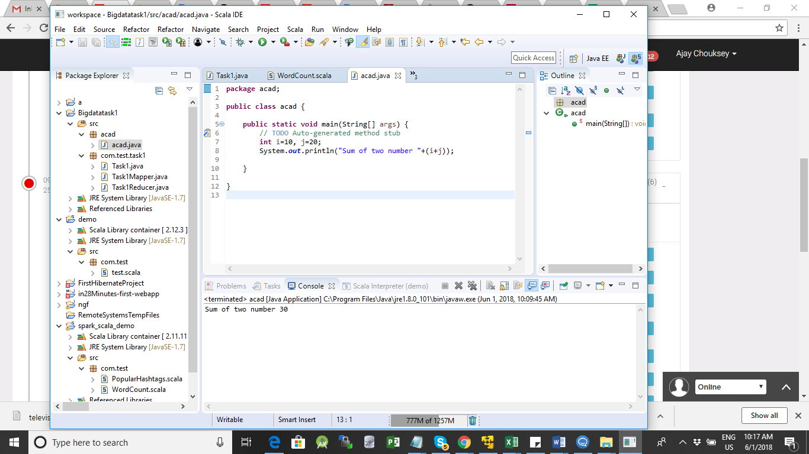

**JAVA Program**

**package** acad;

**public** **class** acad {

**public** **static** **void** main(String[] args) {

// **TODO** Auto-generated method stub

**int** i=10, j=20;

System.***out***.println("Sum of two number "+(i+j));

}

}

2) Rewrite the above code, where, inputs are provided by the user at runtime and the output is

printed.

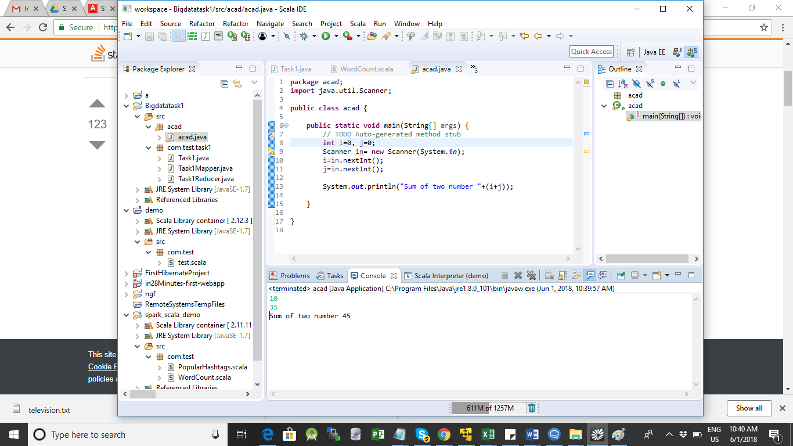

3) Write a program with method name sum() that accepts two parameters from user and print

the sum of two numbers. Output format should be as:

**package** acad;

**import** java.util.Scanner;

**public** **class** acad {

**public** **static** **void** main(String[] args) {

// **TODO** Auto-generated method stub

**int** i=0, j=0;

Scanner in= **new** Scanner(System.***in***);

i=in.nextInt();

j=in.nextInt();

sum s= **new** sum();

s.sumofnumbers(i , j);

//System.out.println("Sum of two number "+(i+j));

}

}

Sum Class

**package** acad;

**public** **class** sum {

**int** sum=0;

**int** sumofnumbers(**int** a , **int** b)

{

**int** x=0;

System.***out***.println("First number is:" + a);

System.***out***.println("Second number is:" + b);

System.***out***.println(" Sum is : "+ (a+b));

**return** x;

}

}

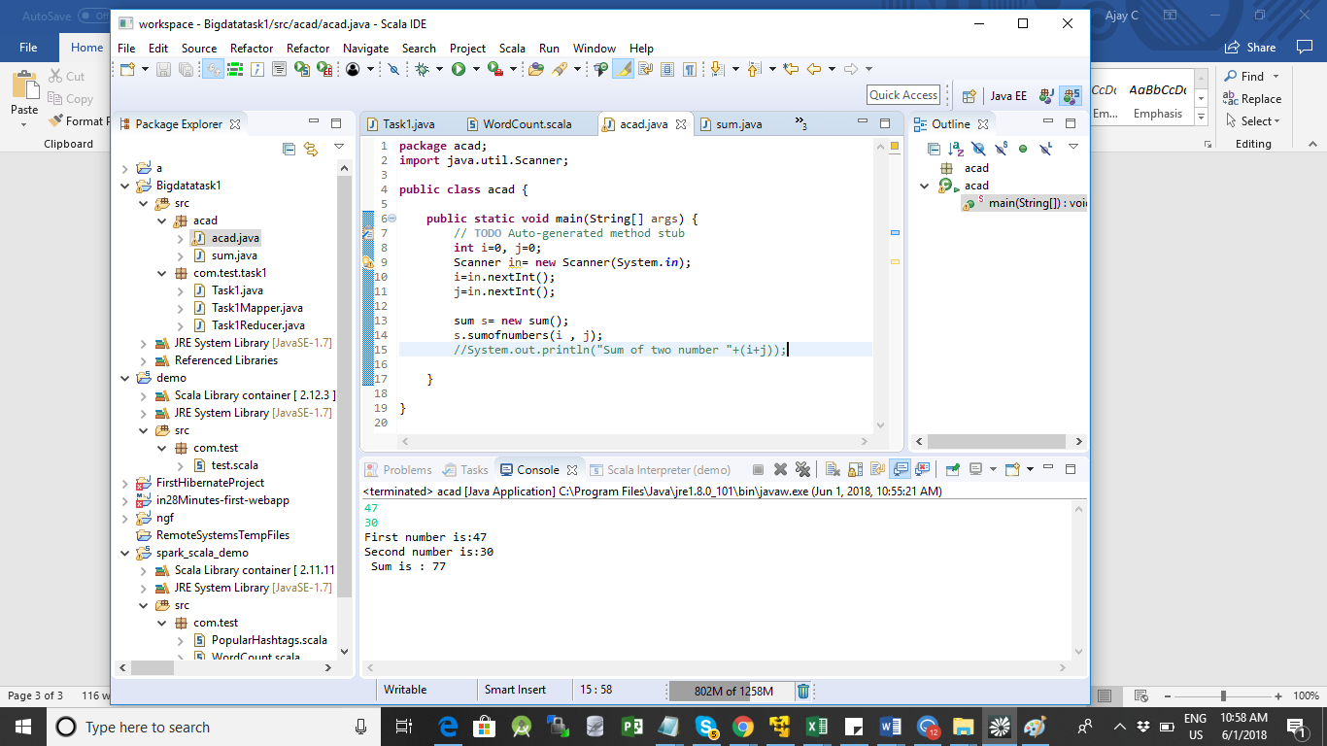

4) Write a program to accepts two numbers from stdin and find all the odd as well as even

numbers present in between them.

Code is below

**public** **class** acad {

**public** **static** **void** main(String[] args) {

// **TODO** Auto-generated method stub

**int** i=0, j=0;

**int** even=0;

Scanner in= **new** Scanner(System.***in***);

i=in.nextInt();

j=in.nextInt();

//even=i%2;

**if**((i%2) == 0)

{

System.***out***.println("Even Numbers ");

**for**(**int** x=i; x<=j; x=x+2)

System.***out***.println(x);

System.***out***.println("Odd Numbers ");

**for**(**int** y=i+1; y<=j; y=y+2)

System.***out***.println(y);

}

**else**

{

System.***out***.println("Odd Numbers ");

**for**(**int** x=i; x<=j; x=x+2)

System.***out***.println(x);

System.***out***.println("Even Numbers ");

**for**(**int** y=i+1; y<=j; y=y+2)

System.***out***.println(y);

}

// even= 1;System.out

/*sum s= new sum();

s.sumofnumbers(i , j); */

//System.out.println("Sum of two number "+(i+j));

}

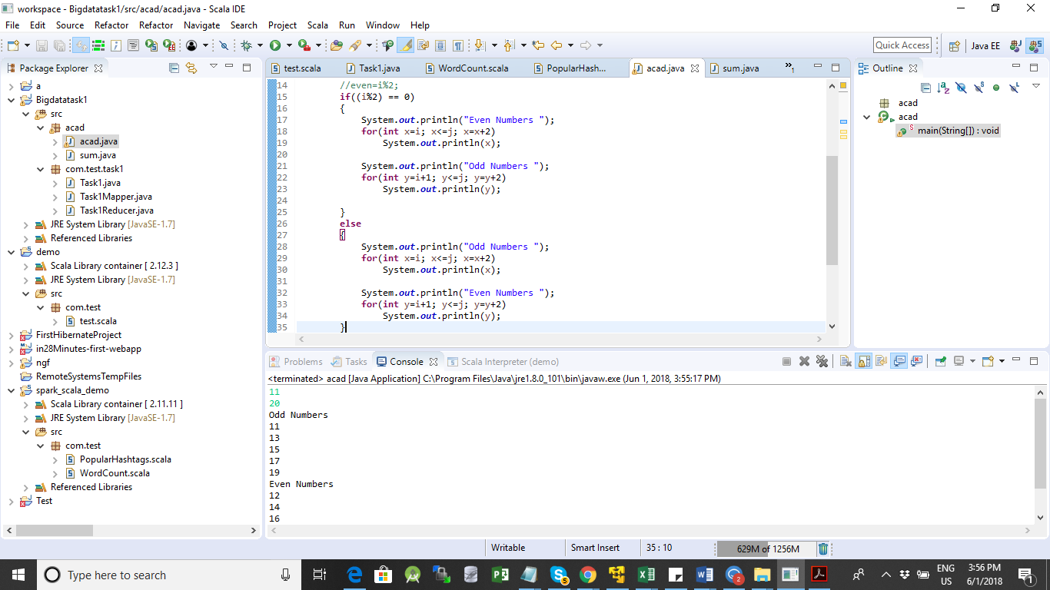

5) Joe is scared to go to school. When her dad asked the reason, joe said she is unable to

complete the task given by her teacher. The task was to find the “first 10 multiples” of the

number entered from stdin . Eg:

Input: 3

O/p:

3 x 1 = 3

3 x 2 = 6

**package** acad;

**import** java.util.Scanner;

**public** **class** acad {

**public** **static** **void** main(String[] args) {

// **TODO** Auto-generated method stub

**int** i=0, j=0;

**int** even=0;

Scanner in= **new** Scanner(System.***in***);

i=in.nextInt();

//j=in.nextInt();

**for** (**int** x=1; x<=10; x++)

System.***out***.println(i*x);

}

]

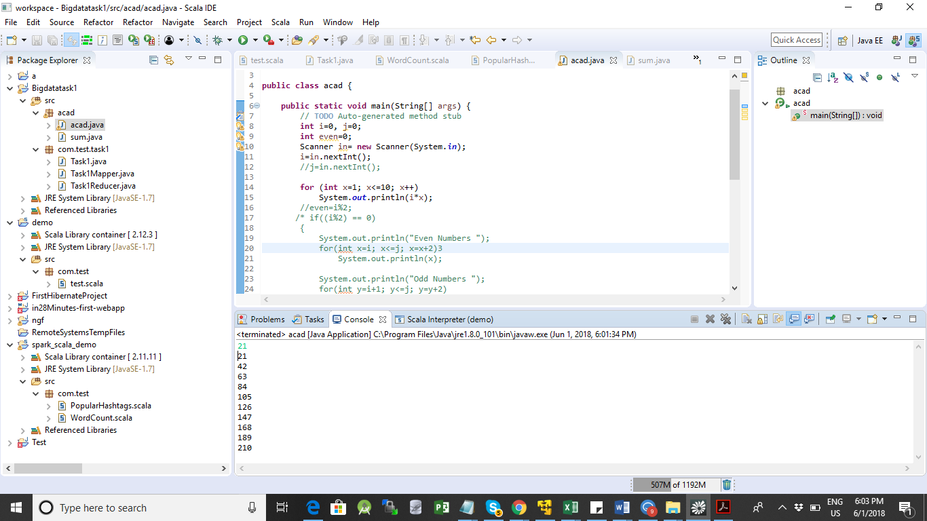

6) Write a program consisting method sum() and demonstrate the concept of method

overloading using this method.

**package** acad;

**import** java.util.Scanner;

**public** **class** acad {

**public** **static** **void** main(String[] args) {

// **TODO** Auto-generated method stub

**int** i=0, j=0;

**int** even=0;

Scanner in= **new** Scanner(System.***in***);

i=in.nextInt();

j=in.nextInt();

sum s= **new** sum();

s.sumofnumbers(i , j);

s.sumofnumbers();

}

**package** acad;

**public** **class** sum {

**int** sum=0;

**int** sumofnumbers(**int** a , **int** b)

{

**int** x=0;

System.***out***.println("First number is:" + a);

System.***out***.println("Second number is:" + b);

System.***out***.println(" Sum is : "+ (a+b));

**return** x;

}

**int** sumofnumbers()

{

**int** x=15, y=34;

System.***out***.println(" Sum is : "+ (x+y));

**return** x+y;

}

}

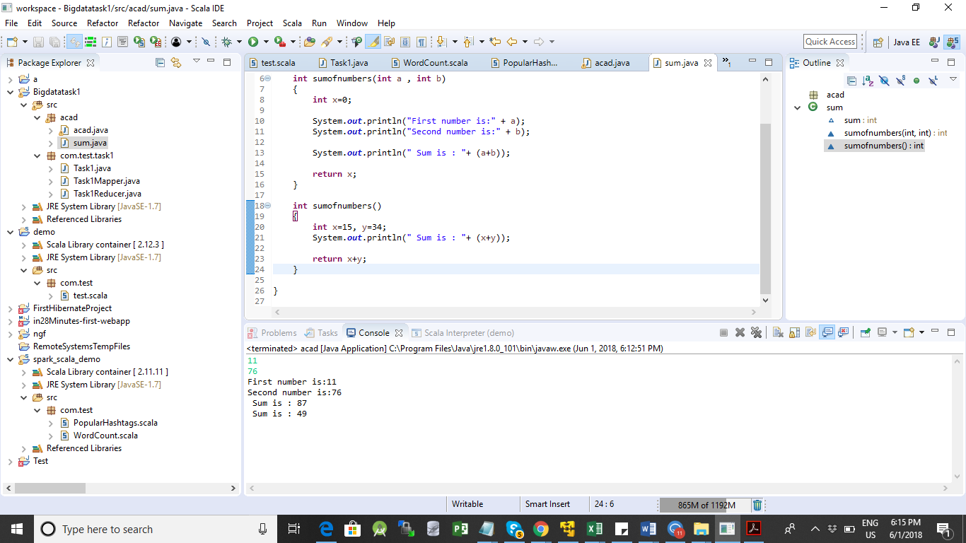

7) Can you overload a method with same return type.? Explain your answer with proper logic.

Ans: Yes it can be overloaded as long as the method signature is different.

In the previous example sumofnumbers() method have the same return type but its overloaded.

8) Write a program in java using Arrays, that sorts the element in descending order.

Program :

**package** acad;

**import** java.util.Arrays;

**import** java.util.Scanner;

**public** **class** acad {

**public** **static** **void** main(String[] args) {

// **TODO** Auto-generated method stub

**int** i=0, j=0;

**int** even=0, max=0;

**int** num[]= { 23,15,7, 17, 97 } ;

/*Scanner in= new Scanner(System.in);

i=in.nextInt();

j=in.nextInt();

sum s= new sum();

s.sumofnumbers(i , j);

s.sumofnumbers(); */

**for** (**int** x=0; x< 5; x++)

{

max=num[x];

**int** temp=0;

**for**(**int** y=x+1; y< 5; y++)

{

**if**(max < num[y])

{

temp=max;

max=num[y];

num[y ]=temp;

}

num[x]=max;

//if()

}

System.***out***.println(num[x]);

}

